**ASSESSMENT**

*NAME-SWARNA LATHA GUVVALA*

*DATE-30/12/2023*

**PRACTICE PROGRAMS:**

TIMEDIFF

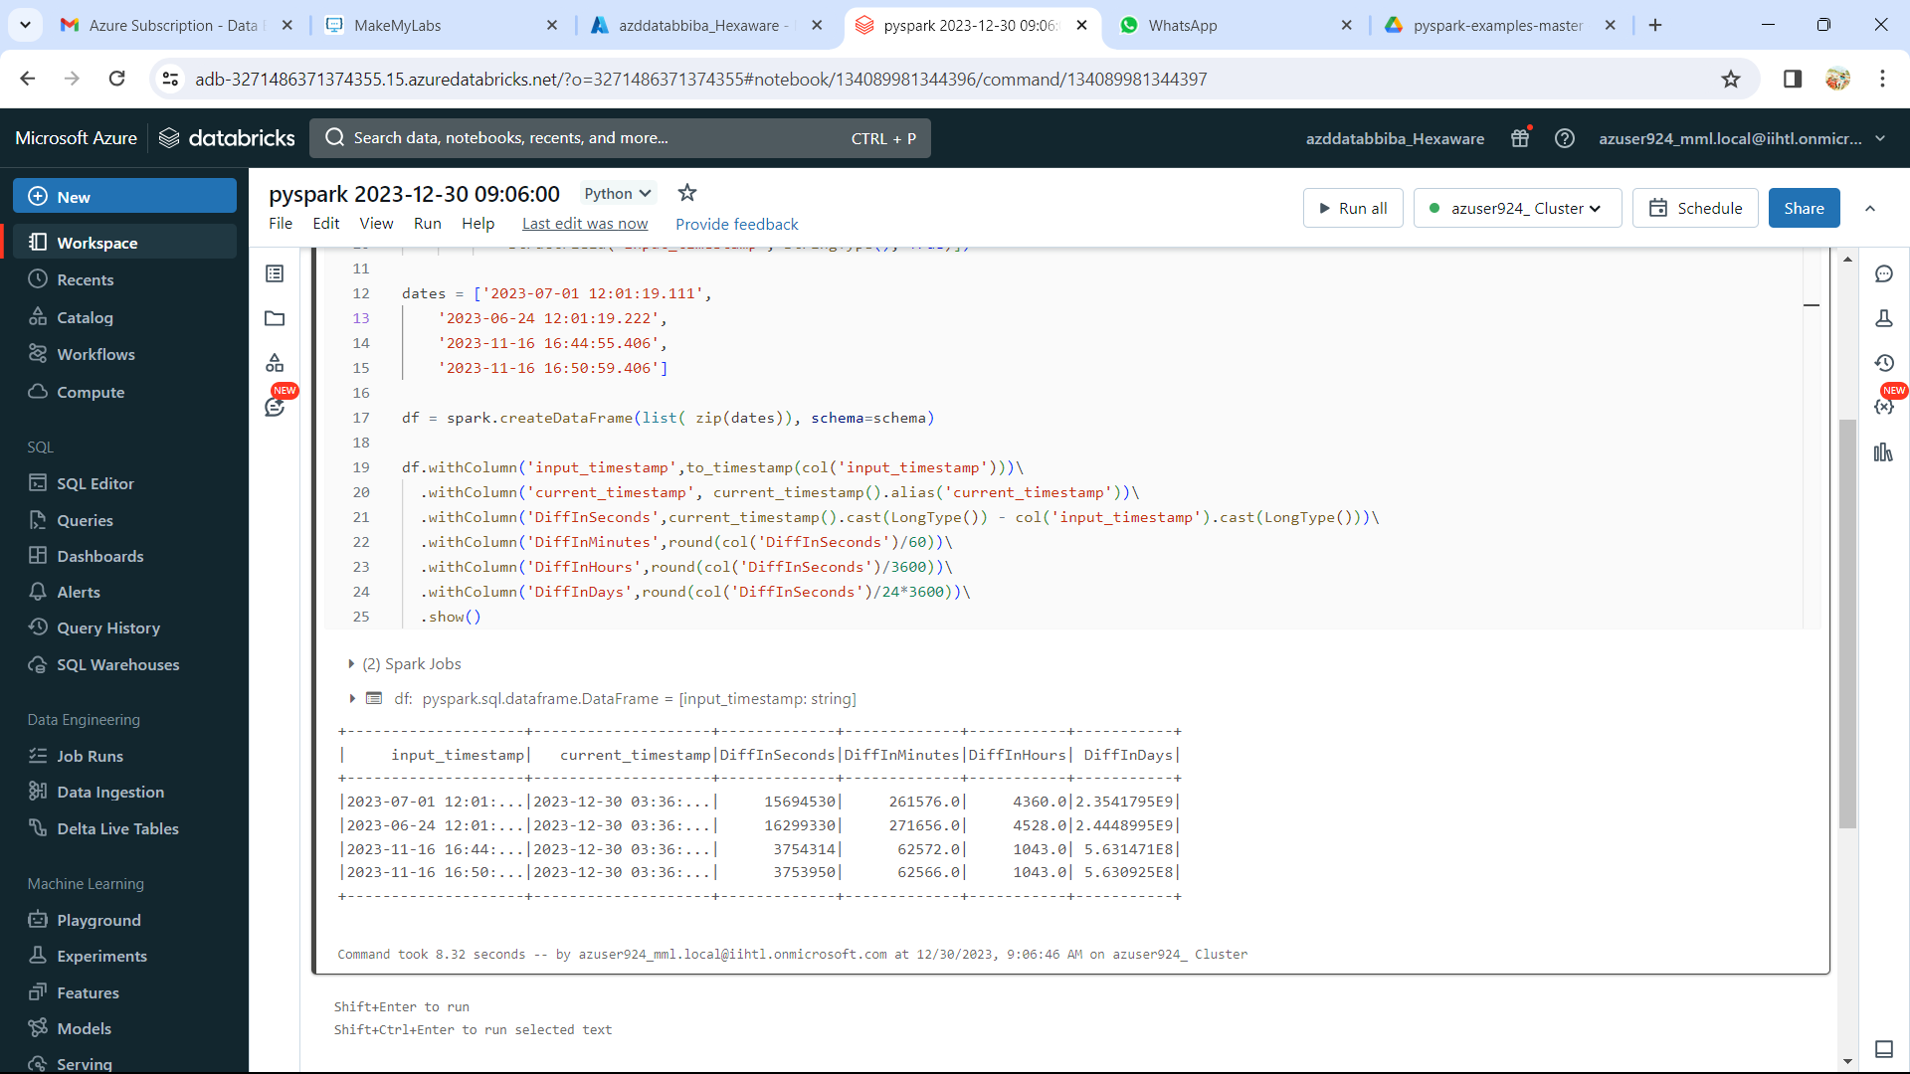

RDD

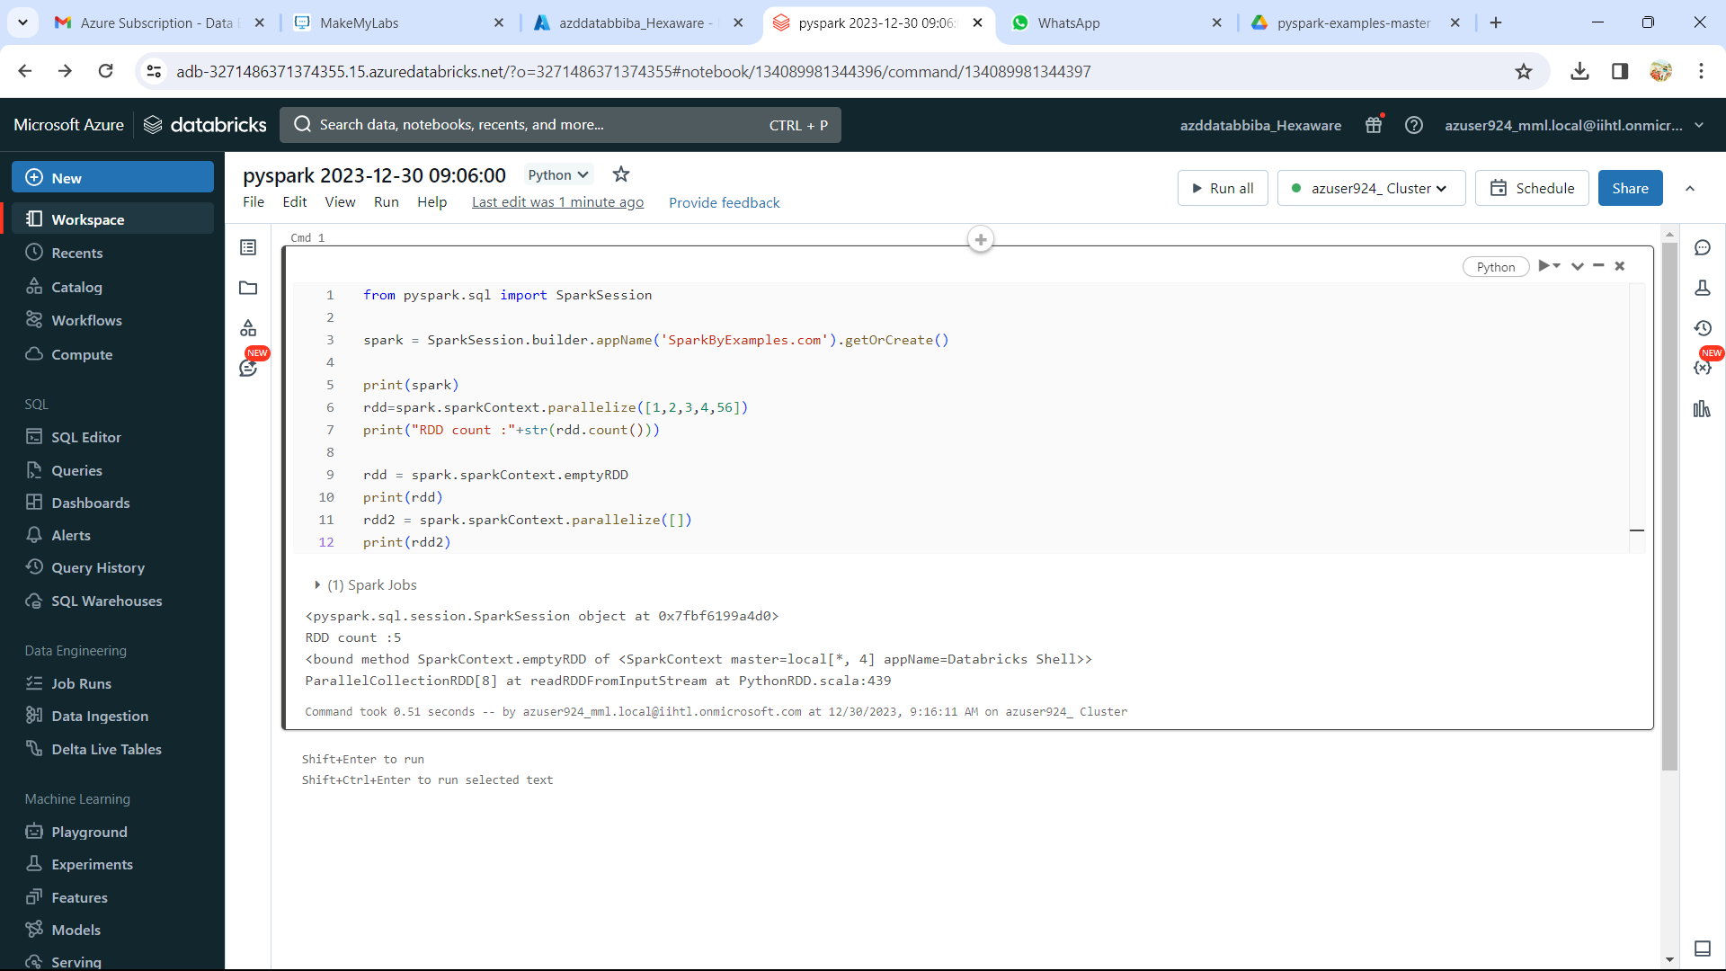

JOIN

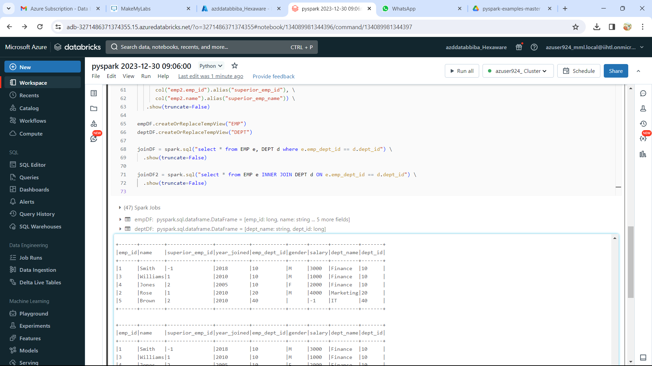

LEFT -ANTI- JOIN

FILTER

GROUPBY

LOOP

ORDERBY

